Vaginoplasty.

After childbirth, women may complain of vaginal laxity, resulting from the stretching of tissue and separation of muscles. This lack of tone can contribute to sexual dysfunction.
Vaginoplasty allows the separated muscles to be brought together and the excess mucous membrane at the back of the vagina to be removed. The outer skin can also be removed to achieve an aesthetic result.
This procedure allows for a narrowing of the vaginal cavity, which can help improve sexual satisfaction.
Our team, together with our gynaecologist, can help you regain your intimate well-being.
Vaginoplasty combined with a labiaplasty can achieve total vaginal rejuvenation.

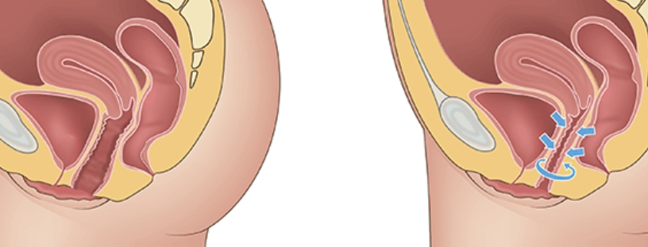
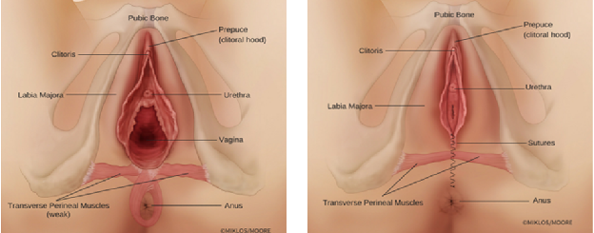

Instructions to the patient
Before the operation :
- After midnight, it is forbidden to eat, drink or smoke.
- It is forbidden to take aspirin (or any other medication containing acetyl salicylic acid) for 10 days before the operation;
- On the day of the operation it is advisable not to wear make-up or nail varnish.
- On the day of the operation it is advisable not to wear contact lenses.
- On the day of the operation it is recommended not to wear jewellery.
- In the morning before the operation, the body must be washed with an antiseptic soap such as Betadermyl (available in pharmacies).
It is compulsory to wear support stockings on the day of your operation.
Please buy the long version up to above the knees. You can buy them in your pharmacy or at the clinic (30€).

After the operation :
- The patient can go home on the day of the operation.
- Take care of your intimate hygiene. Rinse the vagina well with water after every toilet visit.
- Pain may be felt and swelling may occur. In any case, these symptoms will disappear fairly quickly. It is advisable to take Dafalgan (paracetamol) 1 g, 4 times a day, alternating with Ibuprofen 600 mg, 3 times a day, and possibly Oxynorm instant 5mg, 2 x a day. Oxynorm should be stopped in case of nausea.
- Antibiotics will be prescribed and must be taken twice a day for 10 days.
- It is advisable to wear cotton underwear for the first week after the operation and to dry the affected area very carefully.
- It is not recommended to have sexual intercourse in the month following the operation.
- The final results can be evaluated after approximately one month.
- The operation leaves no visible scars and allows the labia minora to retain all their sensitivity.
- It is recommended not to carry heavy objects and not to practice sports for 4 weeks after the operation.
- It is recommended to start with the mucogyne ointment after 2 weeks. Massage this ointment into and out of the vaginal wall to avoid scarring.

